Welcome to the website online tutorial.
Link: https://www.promo-one.co.za/eduvos

Opening the website, you will be presented with the register or login page.

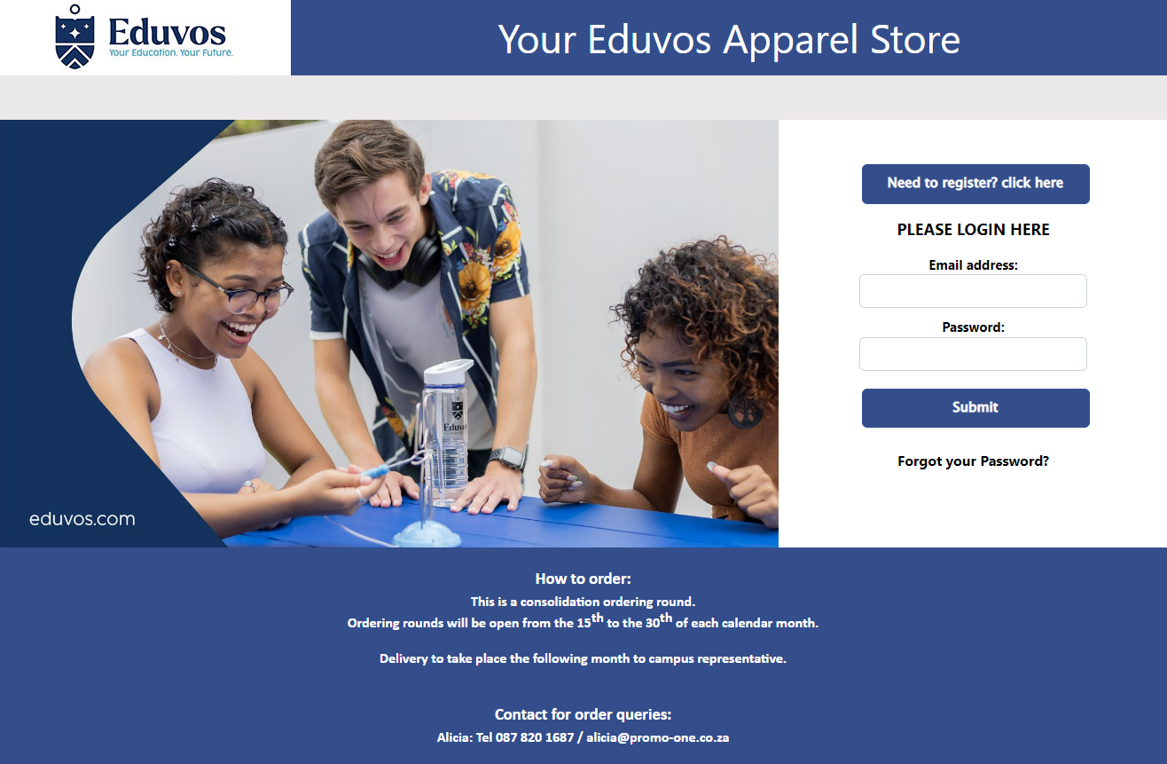

On the register page you can fill in you contact details to create a login profile, afterwards an activation email will be sent to you so please check your inbox aswell as your spam folder.
For Staff registering on the site please check the box “I’m a staff member” this will enable the function on the checkout screen to allow you to request a quote which will be emailed to you in a PDF file.
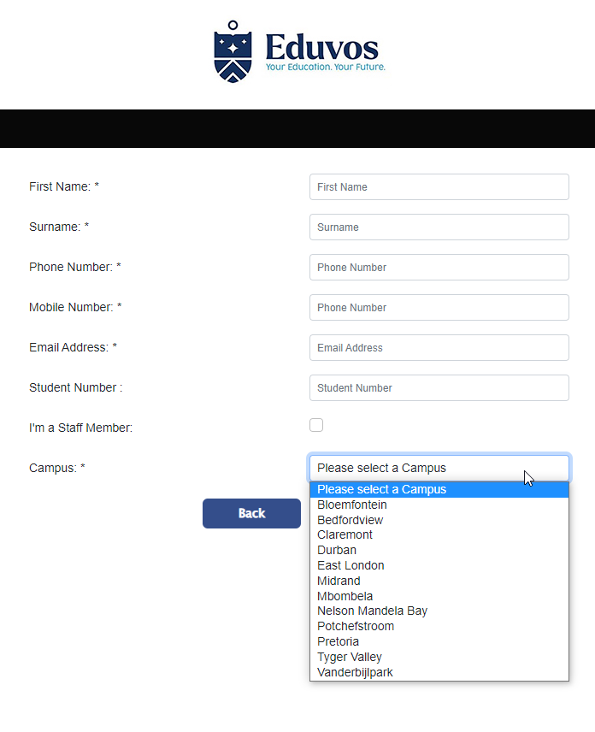

After you login you will see the landing page with featured products. You can now navigate throughout the website.

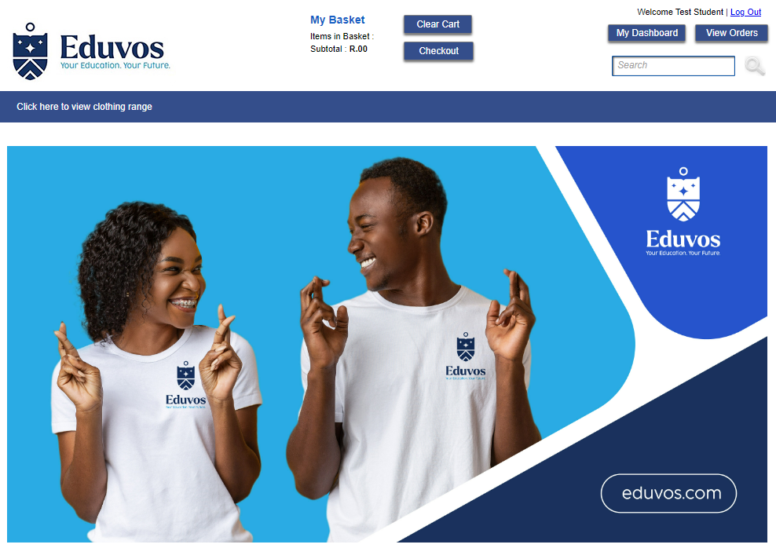
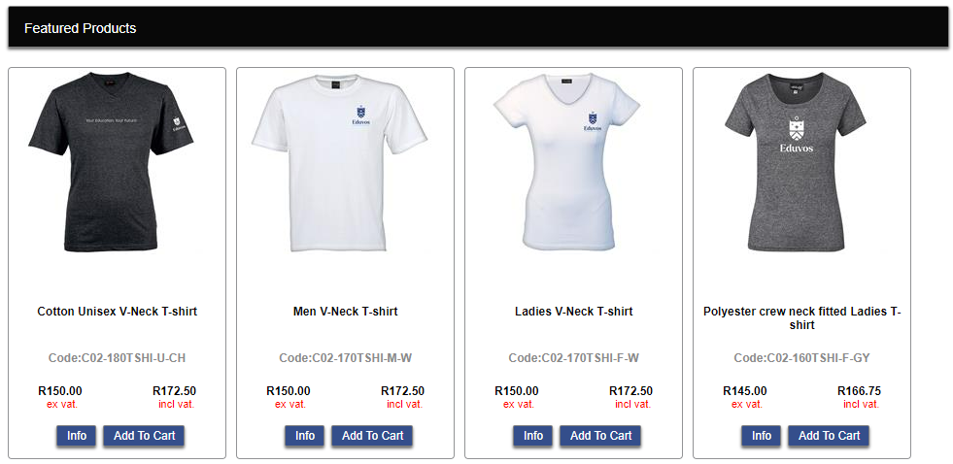

Once you have found that perfect item you can add it to the shopping cart
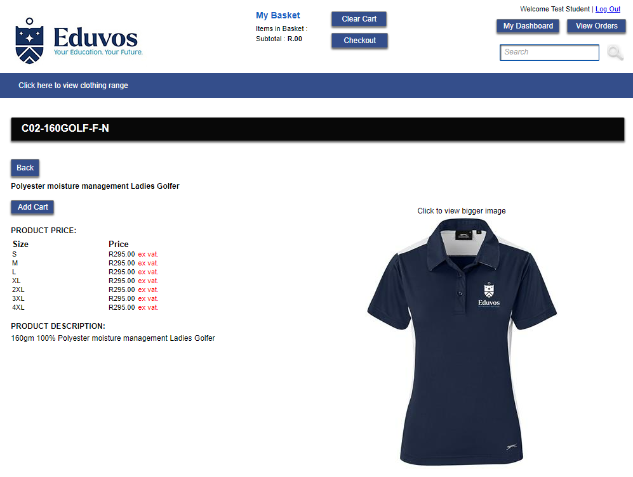

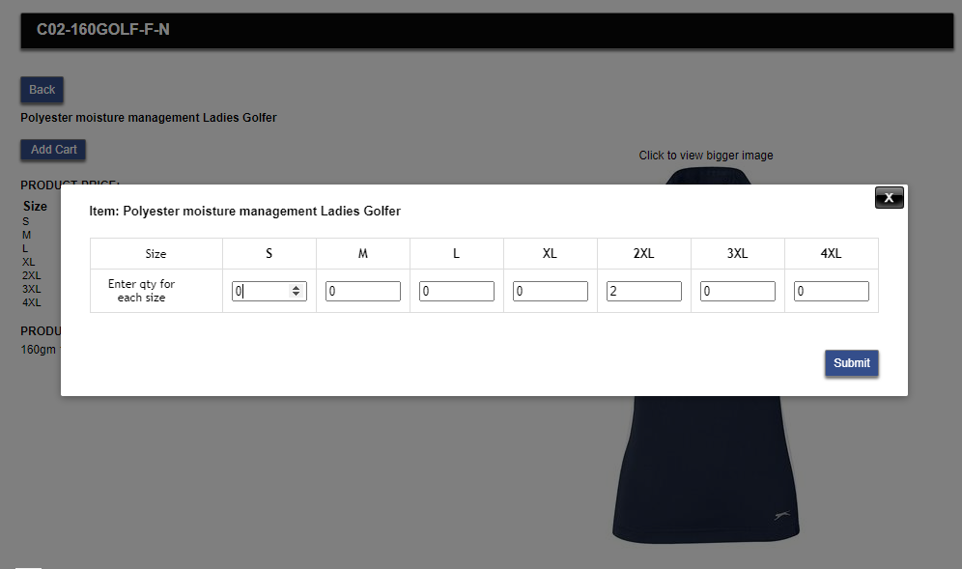
To proceed to checkout click on the shopping basket on the top of your screen
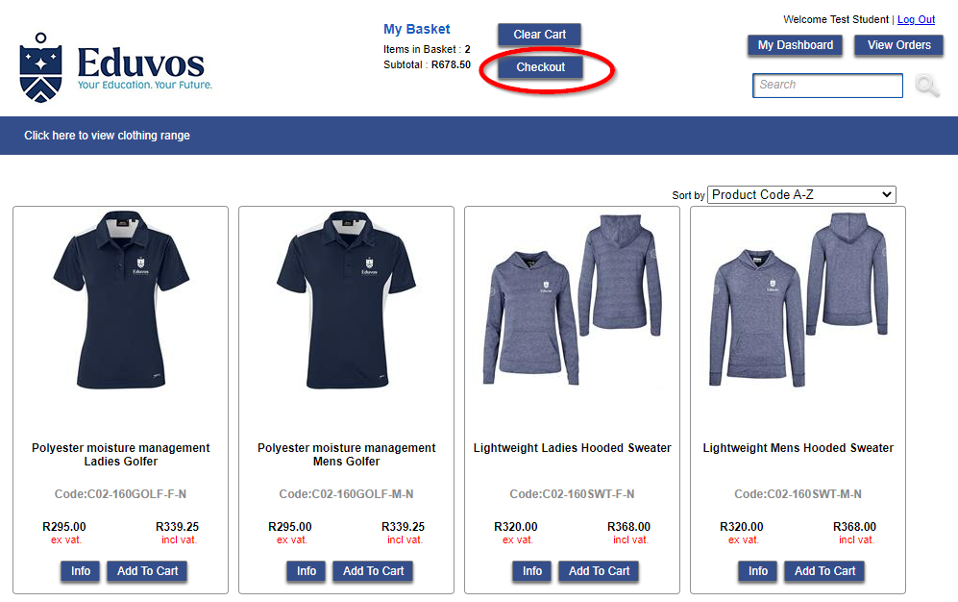

In your basket you welcome to add comments, once you happy you can click on the continue checkout button.
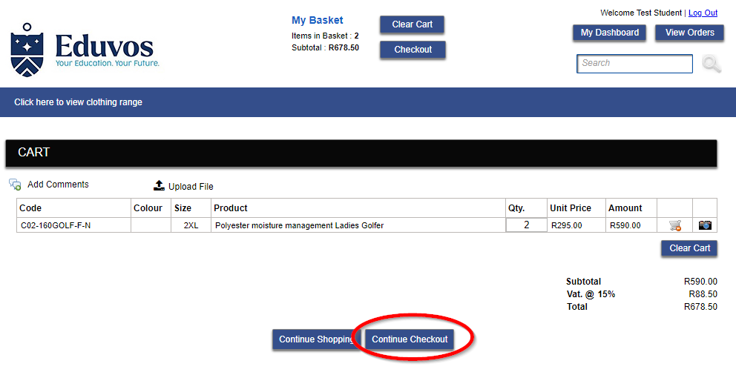
Delivery Options
Choose delivery option and select a Campus to receive this order. Take note of the facilities Administrator who will receive your order on your behalf then you can arrange with them to collect your order.

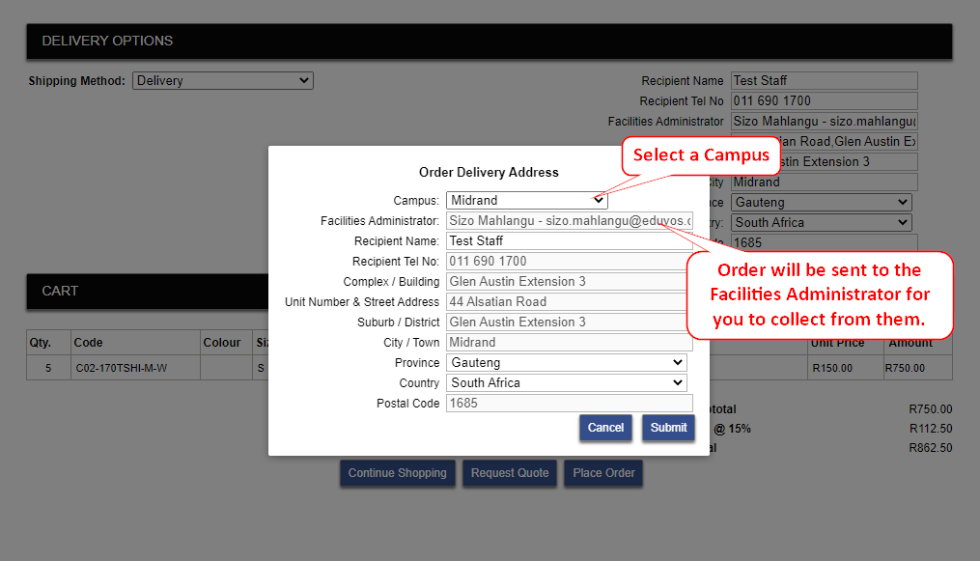

Payment page
Select your payment type which will be Credit Card or Instant EFT via PayU Portal, you will be re-directed to the payment gateway. Once completed you will be returned to the website.

Select PayU from the drop-down list and click finish checkout on the bottom.
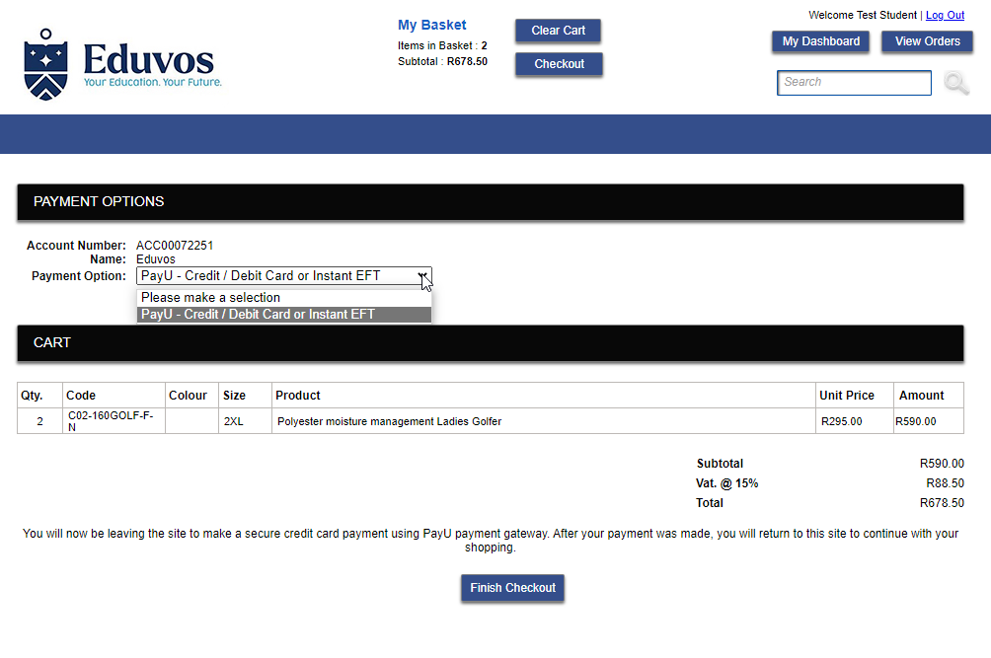

PayU portal
You can now securely enter your details to complete the transaction.
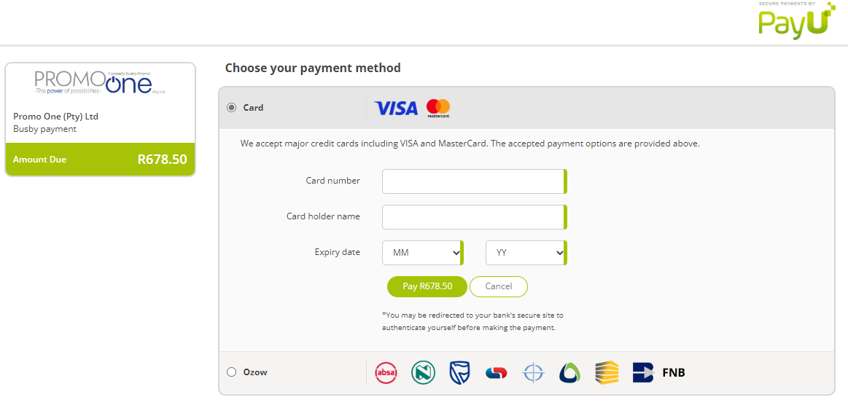

You will now see the confirmation page.
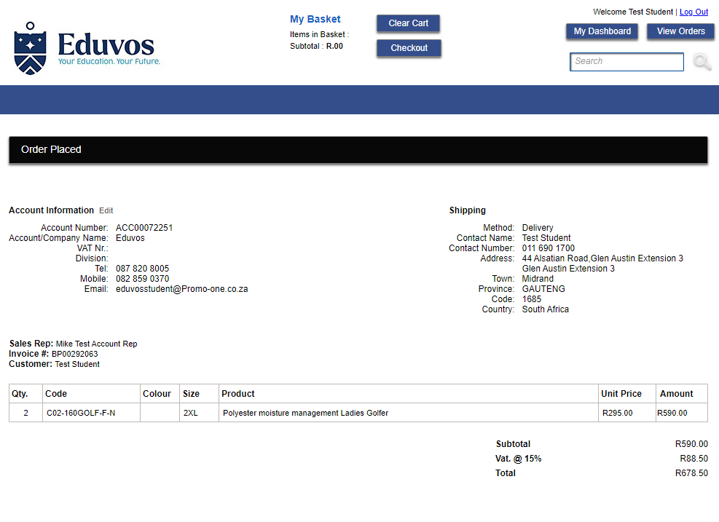
Viewing your order history
Clink on the button “View Order” on the top right of the page will display your order history.
It’s divided into sections for Quotes, placed orders and Fulfilled Orders.
- Quotes - Anything in Quotes is not an official order as we waiting for payment or a Purchase order before moving it to the placed order section.
- Placed Order – These are your current order being packed and delivered.
- Fulfilled – These are orders that have been delivered and invoiced.

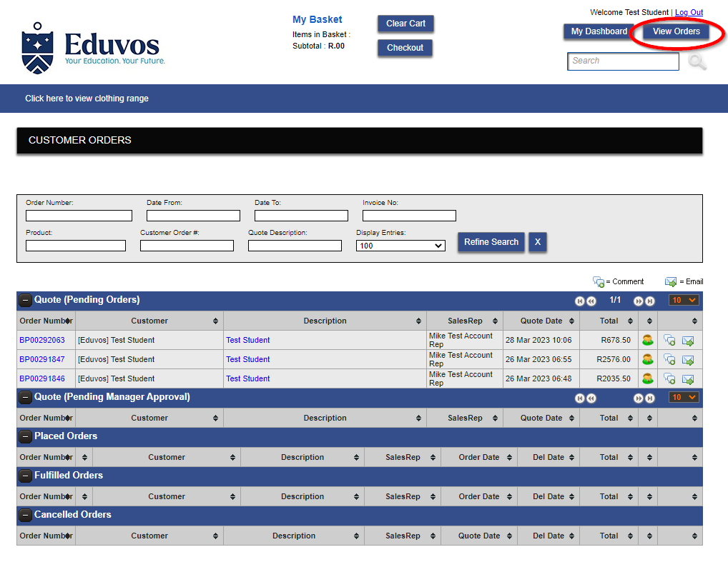
If you hover over the BP number you will notice you can click on the order to open and view.
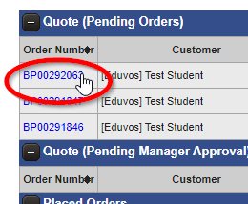
Example of an order
Here you can view and see the progress of your order and when its being shipped etc.
